Two Ottawa Historical Researchers Available
For Work Assignments
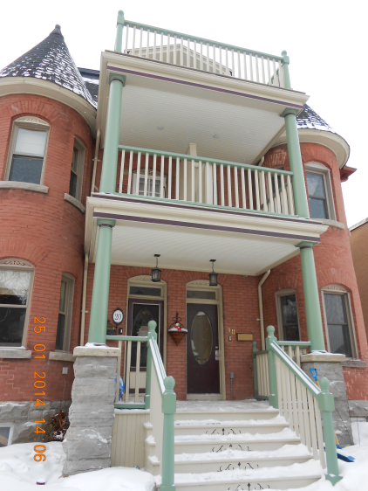
Are you proud of your house and curious about its past? Are you a Real Estate Agent with an older property for sale?
Two experienced historical researchers can find you answers.
Over the last fifteen years our team has prepared 16 social and legal histories of various properties in the Ottawa region - copies can be reviewed in the Ottawa Room at the Main Branch of the Ottawa Public Library 120 Metcalfe Street.
More recently, we have prepared several shorter descriptions for a local real estate company as a marketing tool - these are online at their Blog Site: http://johnkingteam.com/blog/
Reasonable rates based on the size of the project.
Terms: written contract with 50% downpayment.
For more information please contact us at: (613)700–6765 or househistory1@yahoo.ca. Marc & Dave. Thank You !

(Ottawa Street Map 1800’s)
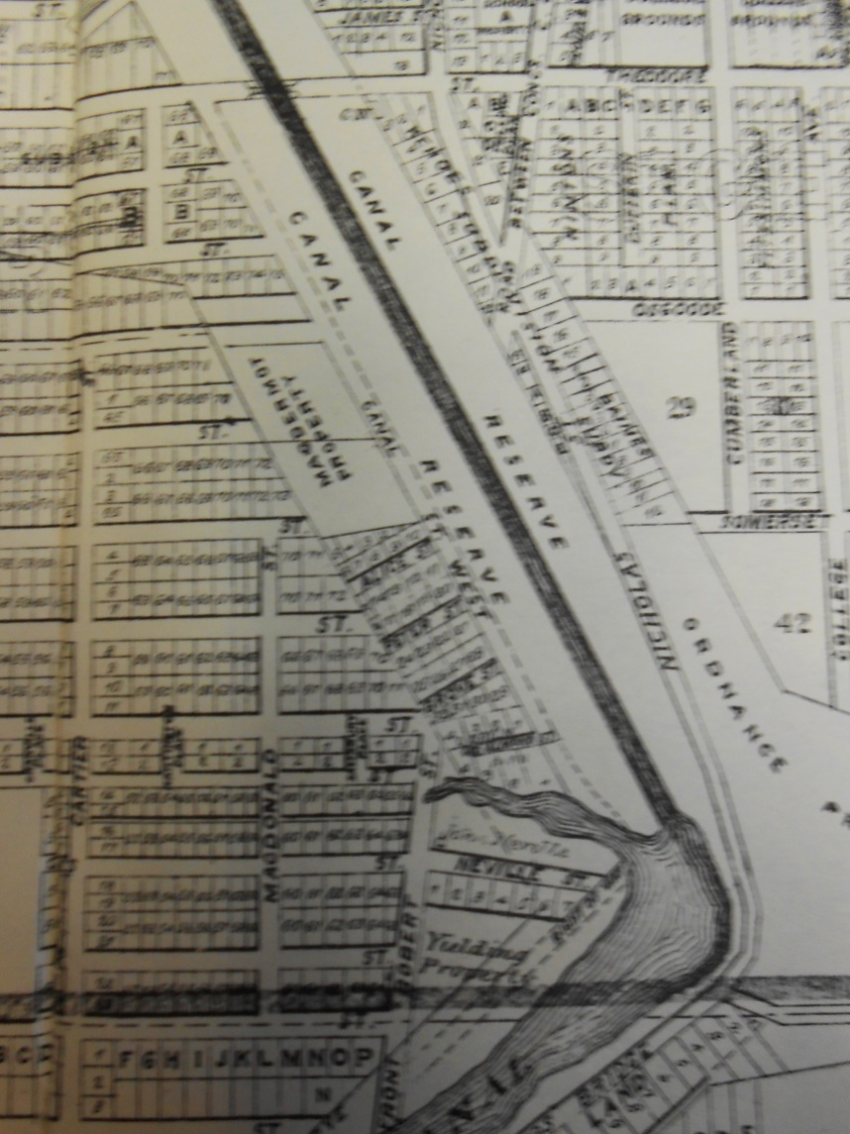
(Minto Park Houses Under
Construction late 1800’s)
